2014 Grad Fundraiser!
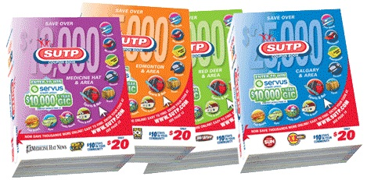

Bowden grad students and SUTP have teamed up to offer your family the 2013/2014 Red Deer SUTP Coupon Book! Not only will you save a lot of money, but you will also be supporting our grad class!
Cost: $20.00 (Our grad class keeps $10 from every book sold!) Cheques can be made out to Bowden School.
Please return your order form and money to the school office. The deadline to submit order forms/money is December 19, 2013.

Student’s Name: Grade / Homeroom Teacher:

Number of Coupon Books ordered:
Total Amount: $


Parent’s Signature:
If you have any questions please feel free to contact Miss Ringheim
dringheim@chinooksedge.ab.ca
403-224-3250

